Voting in a federal election
By mail
A SOCIAL STORY



I will vote at the federal election.
A federal election is when we choose who is part of Australia’s government.
When I vote, I help to choose who is part of Australia’s government.
The Prime Minister will choose the date for the election.

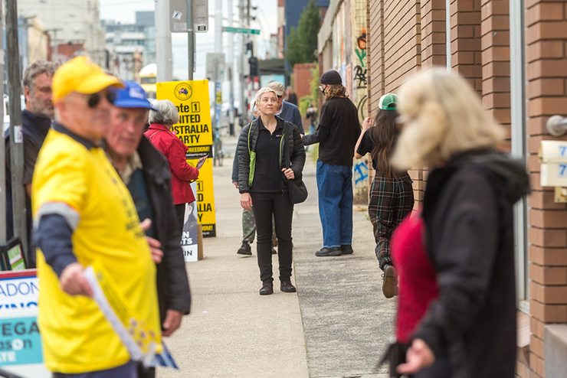

The government makes decisions on our behalf about how to run our country.

It is important for me to have a say about who makes the decisions that affect me.



For me to make the best choice possible I can research the candidates or get advice from someone I trust.

My vote is secret. It’s my choice who I vote for, and I don’t need to tell anyone how I voted unless I want to.

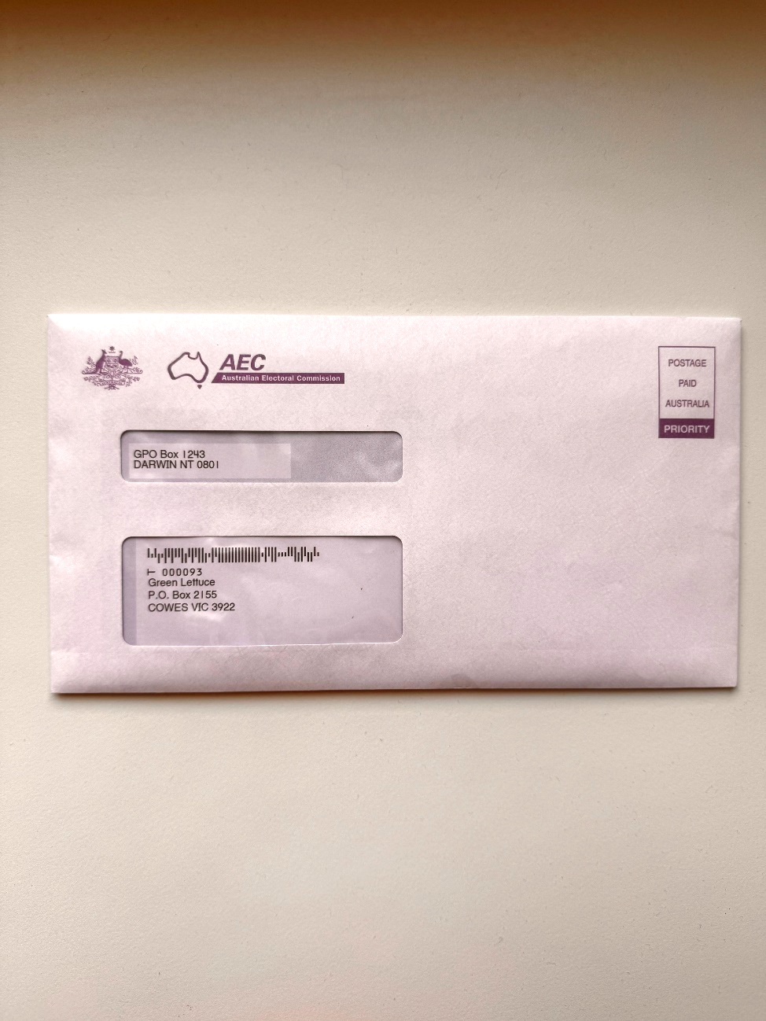

A polling place is a building where you can go to vote.
If I can’t vote in a polling place I can still vote.
I can receive my ballot papers through the mail.
This is called a postal vote.

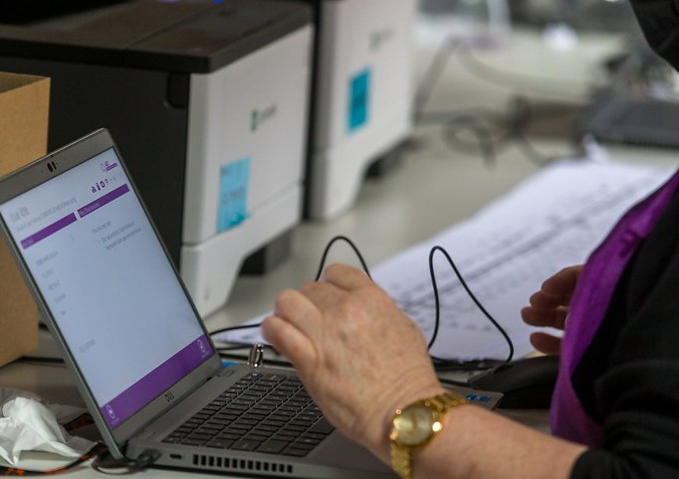

To receive a postal vote, I must apply by filling out a postal vote application.
I can do this by filling out an online application at www.aec.gov.au/pva.
Or I can pick up a postal vote application form from an AEC office.

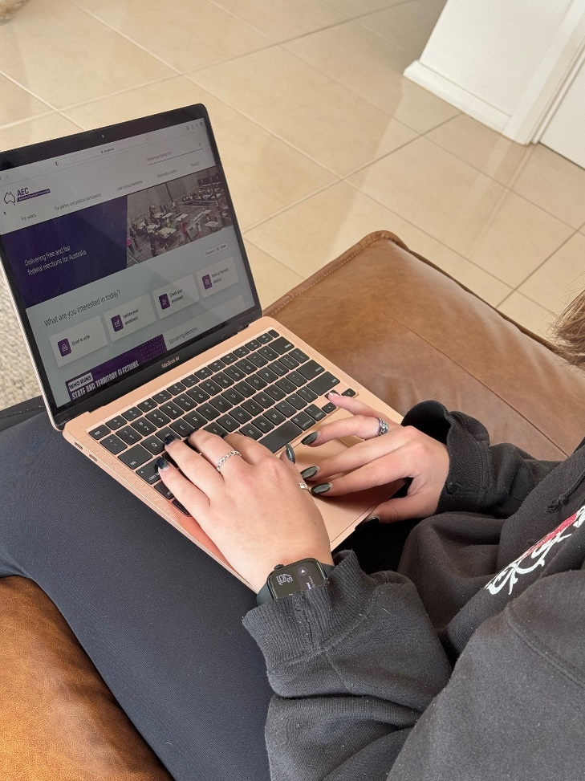

I can apply for a postal vote once the election date is announced.
It is important for me to submit my postal vote application as soon as possible but it must be submitted no later than 6pm on the Wednesday before voting day.

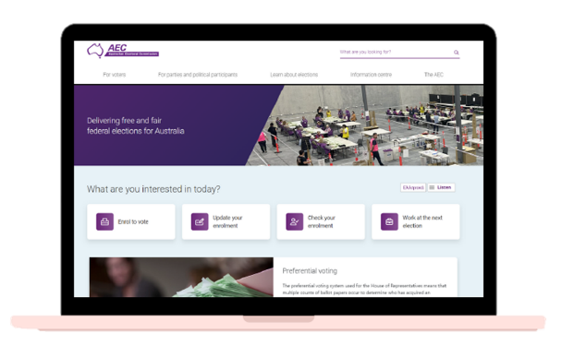

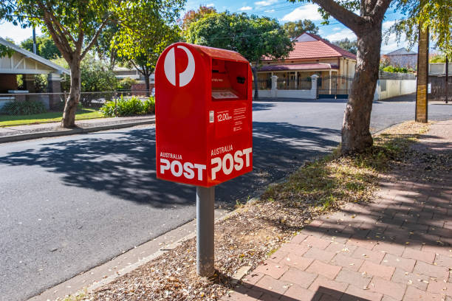



I can email my application to: applications@pva.aec.gov.au

I can send it in the mail:

Australian Electoral Commission
Reply Paid 9988
(My capital city)
(No stamp is needed if posted in Australia)

In person: www.aec.gov.au for my nearest office.


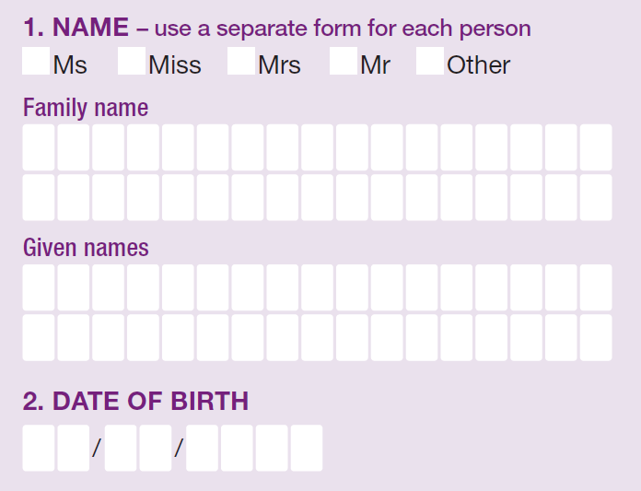

To fill out my postal vote application, I need to gather some information:
If I’m not sure how to do this, I can ask someone I trust for help. For example, a friend, carer or support worker.
I will need to write my full name – this includes my family name (or surname) and then my given names.
I will also need to write the date I was born.

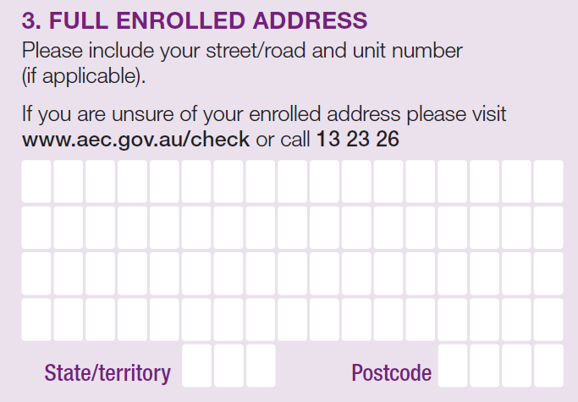

Then, I need to write my address.

This address is the same as the one I gave when I enrolled to vote.

It is probably the address where I live now.

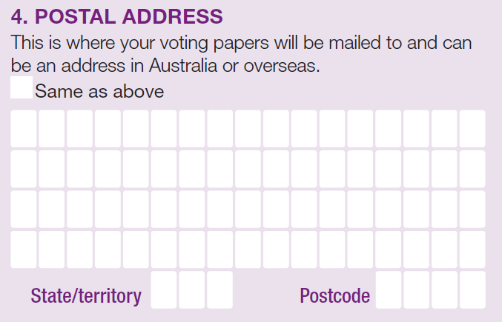

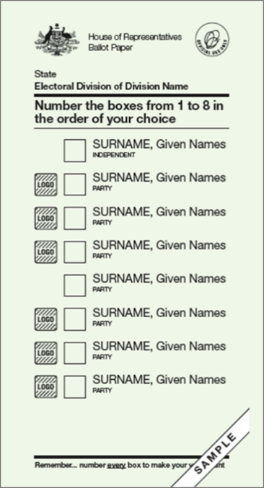

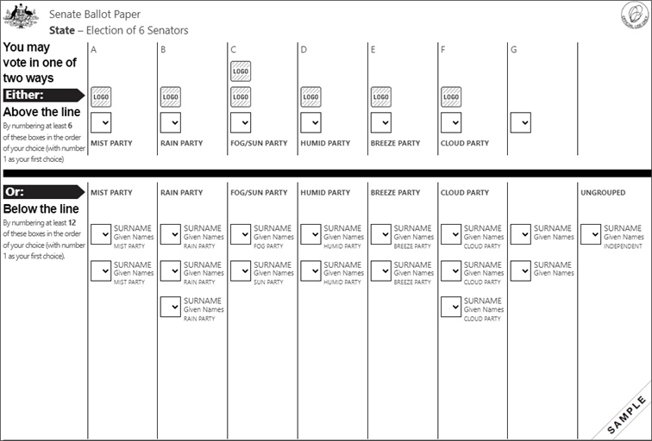

It is important my ballot papers get to me so I need to answer the question; “Where should we send your ballot papers?”
Ballot papers are forms to show who you can vote for.
I will write the address where I would like to receive my ballot papers.







In case the AEC need to contact me with any questions I need to give them:
- My email address (if I have one)
- My mobile phone number
- My home phone number (if I have one)
My mobile phone and home phone number might be the same.


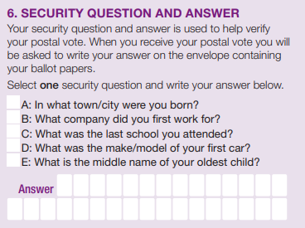
I will need to choose one of the five security questions.

This is like a password.

I can decide which security question and write my own answer.

I need to remember my answer.

I can choose to write the answer down somewhere safe if I am worried about forgetting it.
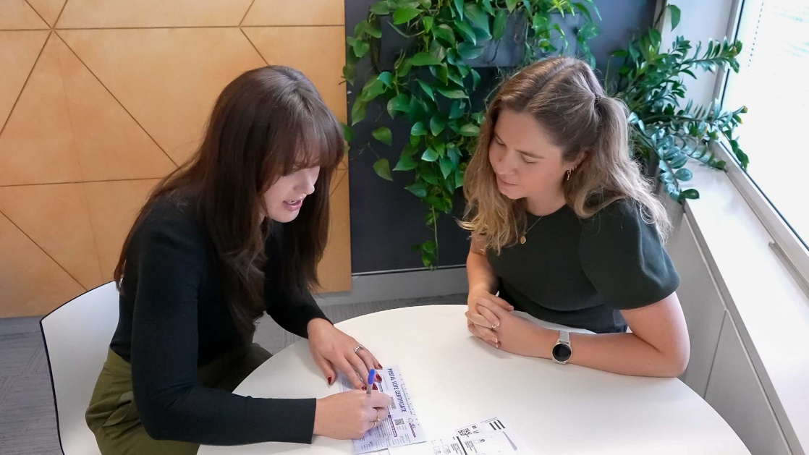

I will need to sign the application and put the date I signed it.

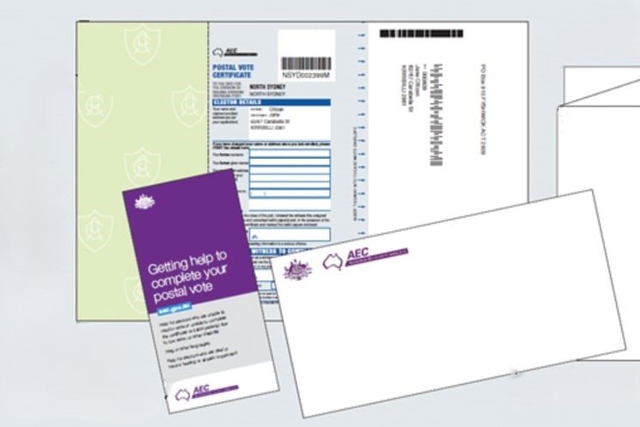

When it is time to vote, the AEC will send me my ballot papers.
I will get 2 ballot papers – a white one and a green one, along with a white envelope.
Attached to the green ballot paper I will have a blue certificate attached.

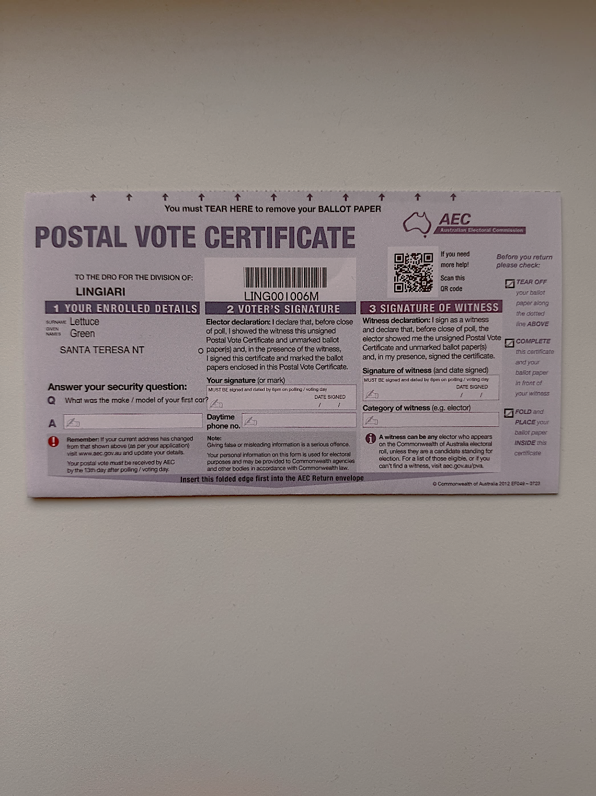

The blue certificate explains who I am.
It has my name, my address and the security question I chose.

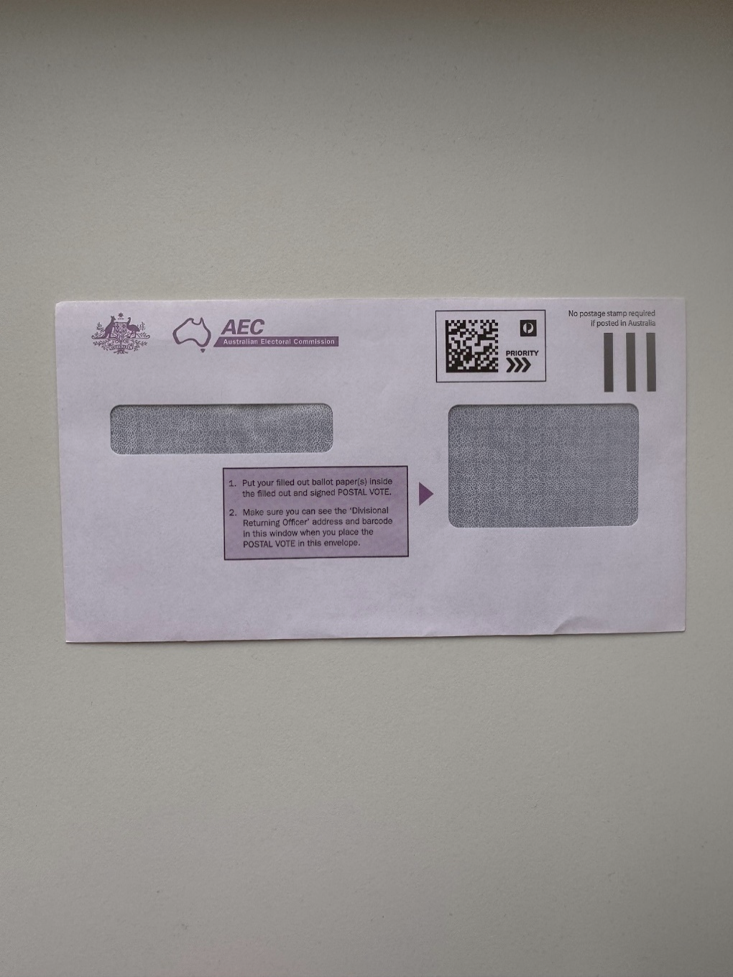

I will also get a white envelope to put my ballot papers and blue certificate in when I have finished voting.



Before I vote I must ask someone to witness my blank ballot papers.

A witness might be someone I know, such as a family member, a friend or a support person.

My witness must be on the electoral roll which means they are able to vote.

Before I fill out my ballot papers, I will show them the blank ballot papers and the blue certificate.

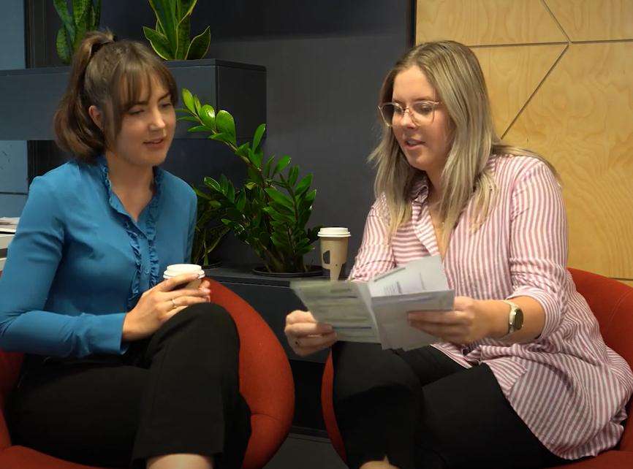

My witness needs to make sure I fill out my own ballot papers.

Before I fill them out, I will show my witness the blank ballot papers and the blue certificate.

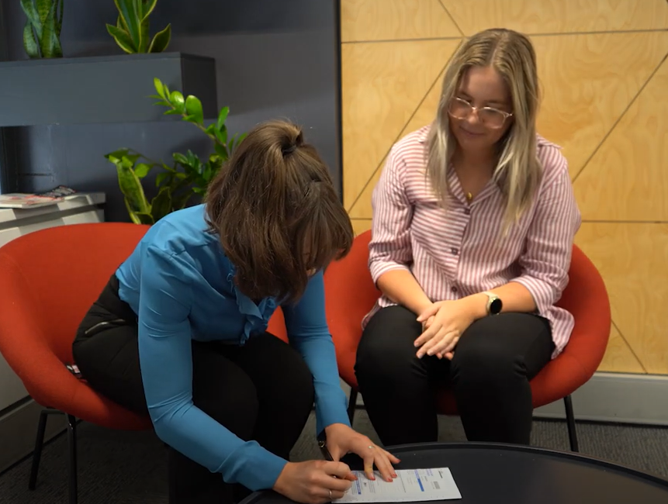

The blue certificate explains who you are and will include:
- Your name
- Your address
- The security question you gave the AEC in your application
I will answer the security question. I need to make sure that this is the same answer I gave on my application.
I may have written this answer down and kept it in a safe place.
After that I will sign my name.



If I am not sure what to do, I can ask my witness to help me fill in my blue certificate.

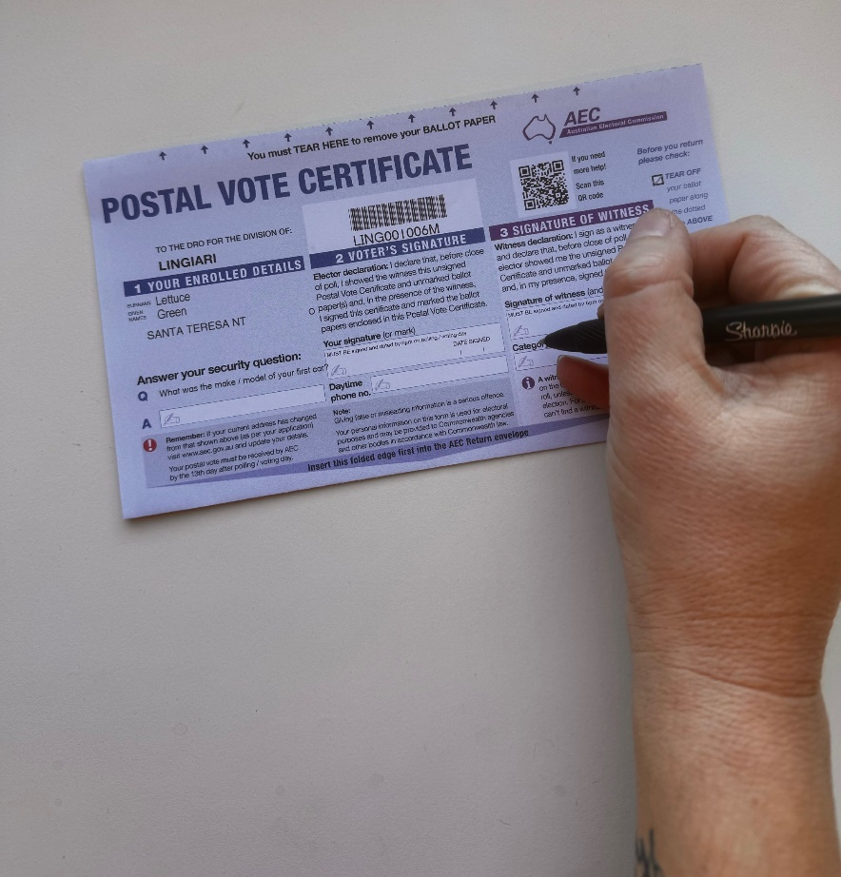

When I have finished filling out the blue certificate, my witness will need to sign it and write the date.
Both you and your witness must sign the blue certificate by 6pm on voting day.

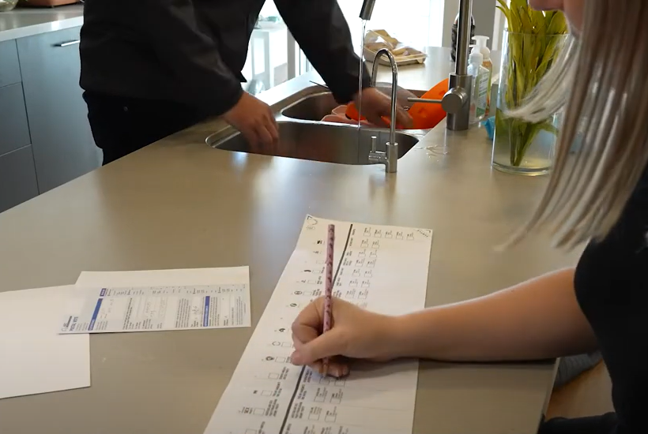

Now I am ready to vote.
I will fill out my ballot papers in the presence of my witness, but I also need to remember my vote is secret.
This means I need to fill out my ballot papers in a way that my witness can not see who I am voting for.


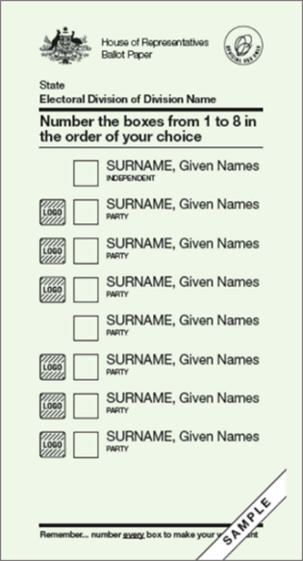

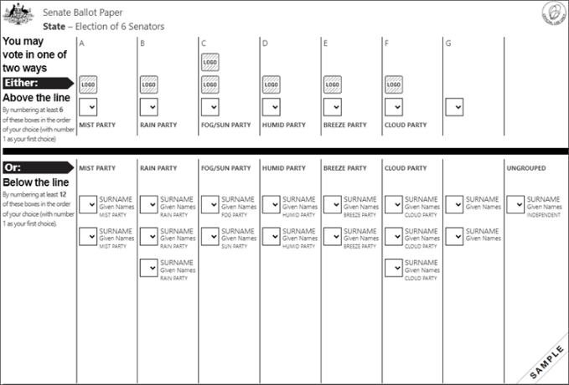



I will need to fill out two ballot papers:
- A green ballot paper for the House of Representatives (also known as the Lower House)
- A white ballot paper for the Senate (also known as the Upper House)

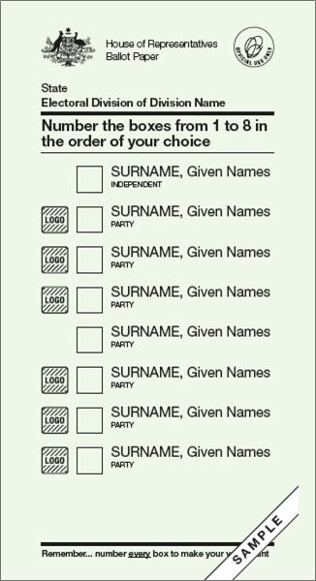

The green ballot paper has a list of all the candidates I can vote for. These are the candidates who want to be part of the House of Representatives.
A candidate is a person who wants to be part of the Parliament.
If the candidate belongs to a political party, it will be written under their name.

On the green ballot paper I need to write 1 in the box next to my favourite candidate, then 2 in the box for my second favourite.
There are instructions on the ballot paper telling me how many numbers to write.
I need to keep writing numbers in order until all the boxes are filled.

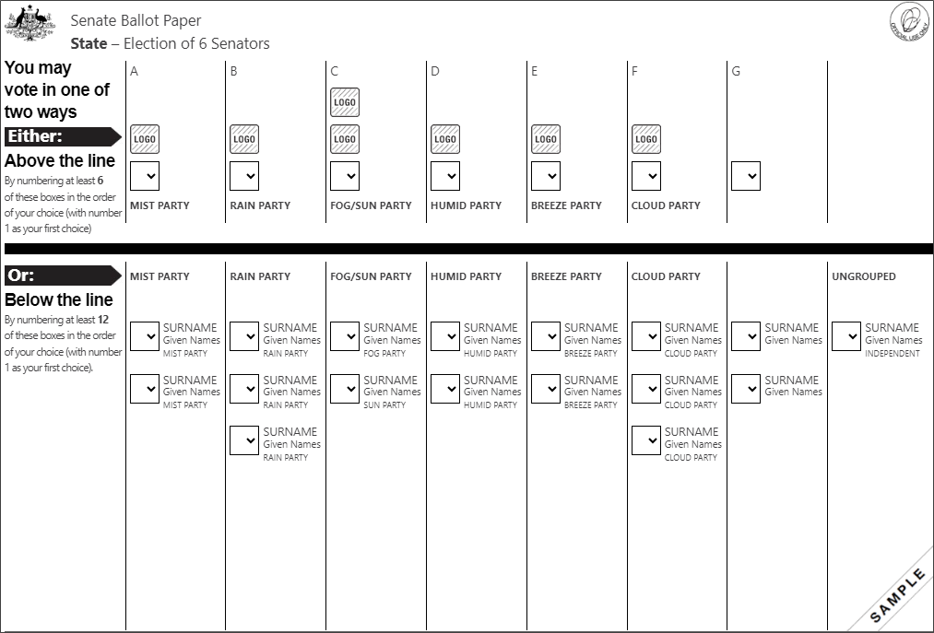

The white ballot paper is for the Senate, and it has a list of all the candidates I can vote for.

There is a list of groups above the black line.
Most of the groups are political parties.
A political party is a group of people who:
- Share some of the same ideas
- Work together on a plan for how government should run our country.
There is a list of candidates below the black line.

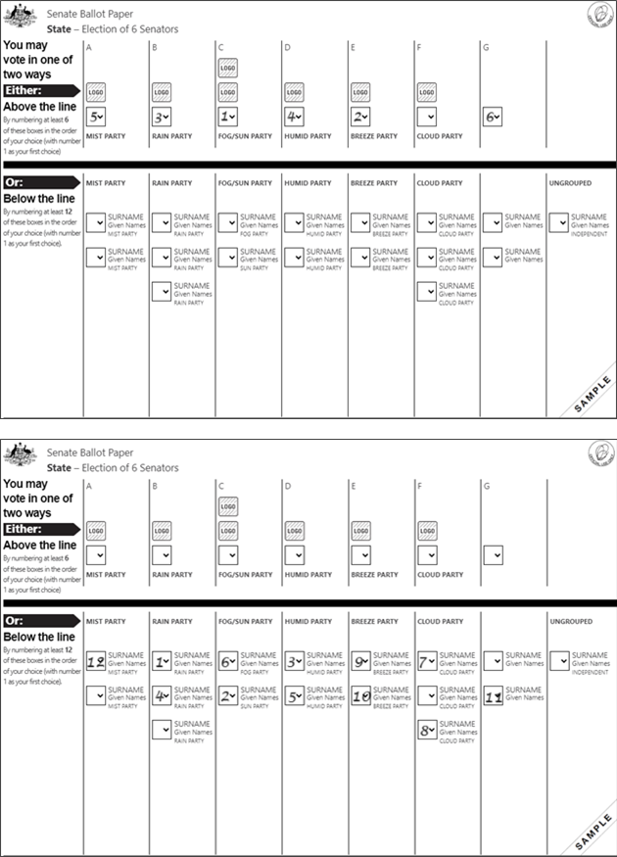
There are two ways I can vote and I get to choose but I cannot do both.
I can vote above the line and vote for political parties.
Or
I can vote below the line and vote for candidates.
I should read and follow the instructions on the ballot paper carefully to make sure my vote counts.

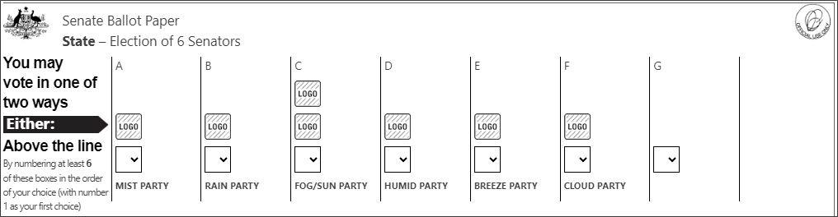
Write numbers 1 – 6
1 = my favourite
To vote above the line, I must number the boxes above the black line in the order I choose.
I will write a number 1 in the box for my favourite group, then 2 in the box for my second favourite.
I need to keep going until I have written numbers 1, 2, 3, 4, 5 and 6.
I must keep numbering boxes above the line until I have filled at least 6 boxes.
I can finish at 6 or keep going and put numbers in as many boxes above the line as I like.
When I have finished numbering the boxes above the line, I have finished filling in my Senate ballot paper.

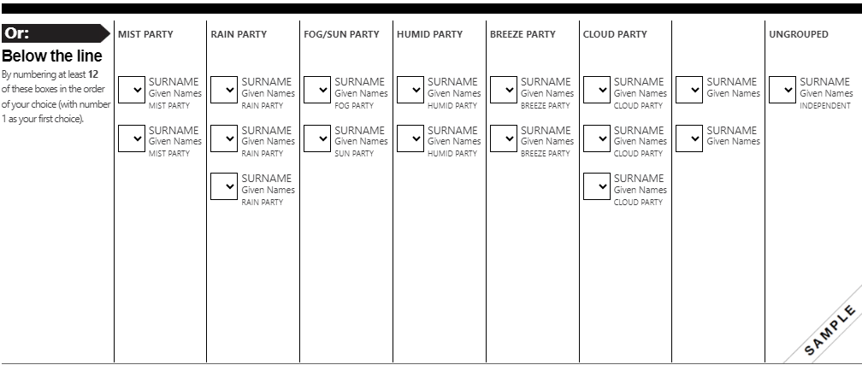
Write numbers 1 – 12
1 = my favourite
To vote below the line, I must number the boxes below the black line in the order I choose.

I will write 1 in the box next to my favourite candidate or person, then 2 in the box for my second favourite.
I need to keep going until I have written numbers 1 to 12.

I must number boxes below the line until I filled in at least 12 boxes.
I can finish at 12 or I can keep going and put numbers in as many boxes below the line as I like.
When I have finished numbering the boxes below the line, I have finished filling in my Senate ballot paper.

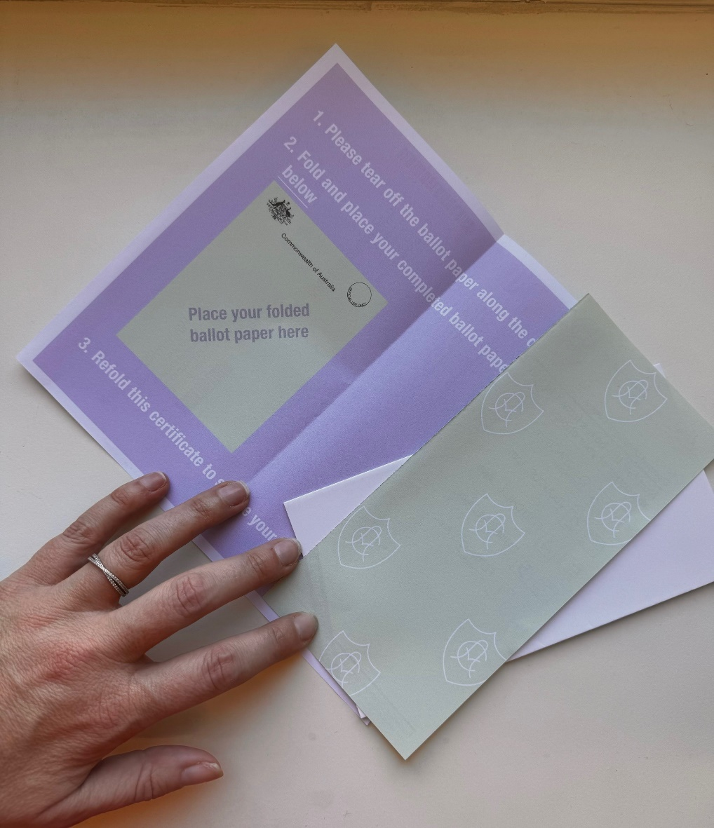
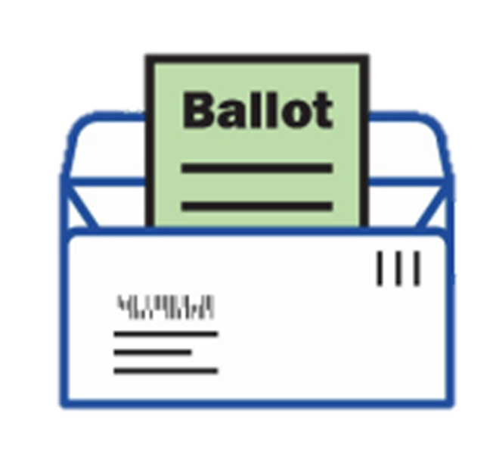
When I have filled out my ballot papers I need to make sure they are in the white envelope correctly ready to be mailed back to the AEC.
I can do this by:
- Folding the blue certificate in half
- Folding my ballot papers
- Putting my ballot papers inside the folded blue certificate
There are instructions to help me do this but I can also ask someone I trust to help me if I am not sure.

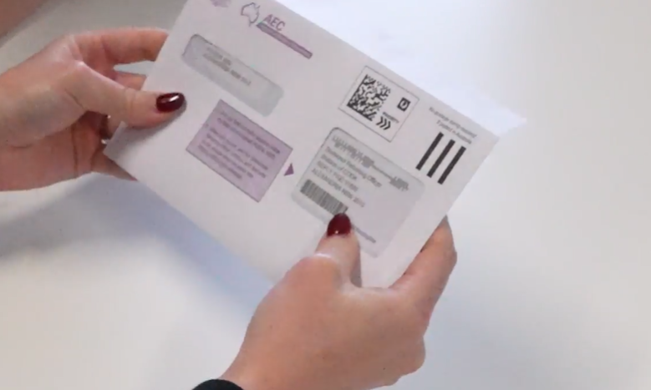

I will put the folded blue certificate with the ballot papers in the white return envelope and seal it.



I must complete my postal vote on or before election day.
It is important that I get my ballot papers back to the AEC as soon as possible.
I must make sure my postal vote has arrived at the AEC no later than 13 days after the election.

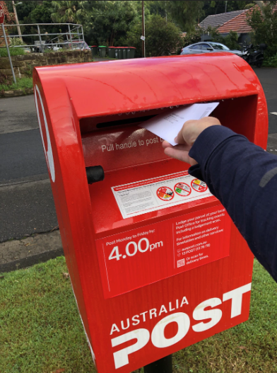

I need to take the white return envelope with my ballot papers sealed inside to an Australia Post mailbox. I don’t need to use a stamp.
I can ask someone I trust to help me with this.



When my white return envelope has been put in the mailbox, I have finished voting.

